LIMKOKWING UNIVERSITY OF CREATIVE TECHNOLOGY
Faculty of Information and Communication Technology
Sierra Leone Campus
PROG315 – Object-Oriented Programming 2
Individual Assignment | Contribution: 10%
Assignment Title | Basic API Structure with Open-Source Software
Module Code | PROG315
Student Name | Alusine G Dumbuya
GitHub Username | Eager1337
Examiner | Amandus Benjamin Coker
Examiner Email | amandus.bcoker@limkokwing.edu.sl
Semester | 04 – March 2026 to July 2026
Issue Date | Week 2
Submission Deadline | Week 4
Date Submitted | 20 April 2026
Framework | Python FastAPI (Open Source)
SDG Alignment | SDG 4 – Quality Education

The Limkokwing Library Management API is a RESTful web service designed for the Limkokwing University library system. It allows students and staff to search the book catalogue, borrow and return books, track overdue items, and supports multiple concurrent users through asynchronous programming. All endpoints follow HTTP REST conventions and return structured JSON responses. Five core endpoints are documented below, each with its purpose, inputs, and outputs described using original examples.

Endpoint 1 – GET /books (Search the Book Catalogue)
This endpoint allows any user to search the library catalogue using up to three optional query parameters: title, author, and category. The search is case-insensitive, and parameters can be combined. If no parameters are provided, the full catalogue is returned. Example: a student looking for programming textbooks sends GET /books?category=Programming and receives a list of all available programming books.

Method | Endpoint | Purpose | Inputs | Output / Response
GET | /books | Search the library catalogue by title, author, or category. Returns all books if no filter is applied. | Query parameters (all optional, all strings): title, author, category. Case-insensitive partial match. | 200 OK. JSON: { total: int, books: [ { id, title, author, category, available: bool } ] }

Endpoint 2 – POST /borrow (Borrow a Book)
This endpoint registers a new borrow transaction. It validates that the user ID exists, the book ID exists, and the book is currently available. On success it creates a borrow record with a due date of 14 days from today, marks the book as unavailable, and returns the record. Example: student Alusine (user_id: 101) borrows Introduction to Algorithms (book_id: 2) and receives a record showing borrow_id: 2, due_date: 2026-05-04.

Method | Endpoint | Purpose | Inputs | Output / Response
POST | /borrow | Register a borrow transaction for a user. Validates user, book, and availability. Sets due date 14 days from today. | JSON request body (required): { user_id: int, book_id: int } | 201 Created. JSON: { message, borrow_record: { borrow_id, user_id, book_id, borrow_date, due_date, returned: false, fine: 0 } }. 400 if unavailable. 404 if not found.

Endpoint 3 – PUT /return (Return a Borrowed Book)
This endpoint processes a book return. It locates the borrow record by borrow_id, verifies that it belongs to the requesting user_id, calculates any overdue fine at USD 1.00 per day past the due date, marks the book as available again, and updates the record. Example: user 101 returns borrow_id 1 which was 7 days overdue and receives fine_amount: 7.00.

Method | Endpoint | Purpose | Inputs | Output / Response
PUT | /return | Process a book return. Calculates overdue fine at $1.00/day and marks book available again. | JSON request body (required): { borrow_id: int, user_id: int } | 200 OK. JSON: { message, fine_amount: float, borrow_record }. 400 if already returned. 403 if wrong user. 404 if not found.

Endpoint 4 – GET /overdue (Track Overdue Books and Fines)
This administrative endpoint returns all borrow records where the due date has passed and the book has not yet been returned. Each record is enriched with the automatically calculated fine, the number of days overdue, the user name, and the book title. Example: a librarian calls GET /overdue and receives a list showing that Alusine has Design Patterns overdue by 7 days with a fine of $7.00.

Method | Endpoint | Purpose | Inputs | Output / Response
GET | /overdue | Return all unreturned books past their due date with auto-calculated fines and days overdue. | No parameters required. | 200 OK. JSON: { total_overdue: int, overdue_records: [ { borrow_id, user_name, book_title, due_date, days_overdue, fine } ] }

Endpoint 5 – GET /books/{book_id} (Single Book Detail)
This endpoint returns the complete details of one specific book by its unique integer ID. It is called when a user selects a search result to see full information before deciding to borrow. Example: GET /books/1 returns { id: 1, title: 'Clean Code', author: 'Robert C. Martin', category: 'Programming', available: true }.

Method | Endpoint | Purpose | Inputs | Output / Response
GET | /books/{book_id} | Return the complete details of one book by its integer ID. | Path parameter: book_id (integer, required). | 200 OK. JSON: { id, title, author, category, available }. 404 Not Found if book_id does not exist.

Client – API – Server Interaction Diagram
The diagram below shows how the three system layers interact during a standard POST /borrow request. The client application sends an HTTP request with a JSON body. FastAPI validates the data using Pydantic schemas, executes the business logic (availability check, due date calculation, record creation), updates the in-memory data store, and returns a structured JSON response. The async event loop allows multiple such requests to execute concurrently without blocking.

┌─────────────────────────────────────────────────────────┐
│ CLIENT (Browser / Mobile App) │
└──────────────────────────┬──────────────────────────────┘
HTTP Request ──────────▶ │ POST /borrow
│ Body: { "user_id": 101, "book_id": 2 }
▼
┌─────────────────────────────────────────────────────────┐
│ FASTAPI SERVER (Business Logic Layer) │
│ Step 1 ▸ Validate user_id & book_id (Pydantic) │
│ Step 2 ▸ Check book availability in data store │
│ Step 3 ▸ Create borrow record, set due_date +14 days │
│ Step 4 ▸ Set book["available"] = False │
└──────────────────────────┬──────────────────────────────┘
▼
┌─────────────────────────────────────────────────────────┐
│ DATA STORE (books_db / borrows_db / users_db) │
│ In-memory Python dicts (replaceable with DB) │
└──────────────────────────┬──────────────────────────────┘
HTTP Response ◀──────── │ 201 Created
│ Body: { "message": "...", "borrow_record": { ... } }
▼
┌─────────────────────────────────────────────────────────┐
│ CLIENT displays borrow confirmation to user │
└─────────────────────────────────────────────────────────┘

PART B – IMPLEMENTATION
The implementation uses Python FastAPI with async/await throughout. All request inputs are validated automatically using Pydantic type-annotated schemas. The Swagger UI at /docs is auto-generated from the code. Screenshots below confirm each endpoint running successfully on a local server (uvicorn main:app --reload) accessed at http://127.0.0.1:8000.

B.1 Complete Source Code (main.py)

from fastapi import FastAPI, HTTPException, Query
from pydantic import BaseModel
from typing import Optional
import asyncio
from datetime import date, timedelta
app = FastAPI(
title="Limkokwing Library API",
description="A digital library management system for Limkokwing University Sierra Leone",
version="1.0.0"
)
# In-memory "database"
books_db: dict[int, dict] = {
1: {"id": 1, "title": "Clean Code", "author": "Robert C. Martin",
"category": "Programming", "available": True},
2: {"id": 2, "title": "Introduction to Algorithms", "author": "Thomas H. Cormen",
"category": "Computer Science", "available": True},
3: {"id": 3, "title": "Design Patterns", "author": "Gang of Four",
"category": "Software Engineering", "available": False},
4: {"id": 4, "title": "Python Crash Course", "author": "Eric Matthes",
"category": "Programming", "available": True},
5: {"id": 5, "title": "The Pragmatic Programmer", "author": "David Thomas",
"category": "Software Engineering", "available": True},
}
borrows_db: dict[int, dict] = {
1: {
"borrow_id": 1,
"user_id": 101,
"book_id": 3,
"borrow_date": str(date.today() - timedelta(days=20)),
"due_date": str(date.today() - timedelta(days=6)),
"returned": False,
"fine": 0.0,
}
}
users_db: dict[int, dict] = {
101: {"user_id": 101, "name": "Alusine Dumbuya", "email": "alusine@limkokwing.edu.sl"},
102: {"user_id": 102, "name": "Fatmata Kamara", "email": "fatmata@limkokwing.edu.sl"},
103: {"user_id": 103, "name": "Mohamed Conteh", "email": "mohamed@limkokwing.edu.sl"},
}
borrow_counter: int = 2 # next borrow ID
# Pydantic schemas
class BorrowRequest(BaseModel):
user_id: int
book_id: int
class ReturnRequest(BaseModel):
borrow_id: int
user_id: int
class BookCreate(BaseModel):
title: str
author: str
category: str
# Helper
FINE_PER_DAY: float = 1.0 # USD per overdue day
def calculate_fine(due_date_str: str) -> float:
due = date.fromisoformat(due_date_str)
today = date.today()
if today > due:
return round((today - due).days * FINE_PER_DAY, 2)
return 0.0

# ENDPOINT 1 – GET /books (Search)
@app.get("/books", summary="Search books by title, author, or category")
async def search_books(
title: Optional[str] = Query(None, description="Partial title to search"),
author: Optional[str] = Query(None, description="Partial author name to search"),
category: Optional[str] = Query(None, description="Book category to filter by"),
) -> dict:
"""
Returns a list of books matching the given search criteria.
All parameters are optional and case-insensitive.
"""
results = list(books_db.values())
if title:
results = [b for b in results if title.lower() in b["title"].lower()]
if author:
results = [b for b in results if author.lower() in b["author"].lower()]
if category:
results = [b for b in results if category.lower() in b["category"].lower()]
return {
"total": len(results),
"books": results
}
# ENDPOINT 2 – POST /borrow (Borrow a book)
@app.post("/borrow", summary="Borrow a book", status_code=201)
async def borrow_book(request: BorrowRequest) -> dict:
"""
Allows a registered user to borrow an available book.
Returns a borrow record with the due date (14 days from today).
"""
global borrow_counter
# Validate user
if request.user_id not in users_db:
raise HTTPException(status_code=404, detail="User not found")
# Validate book
book = books_db.get(request.book_id)
if not book:
raise HTTPException(status_code=404, detail="Book not found")
if not book["available"]:
raise HTTPException(status_code=400, detail="Book is currently not available")
# Create borrow record
borrow_date = date.today()
due_date = borrow_date + timedelta(days=14)
record: dict = {
"borrow_id": borrow_counter,
"user_id": request.user_id,
"book_id": request.book_id,
"borrow_date": str(borrow_date),
"due_date": str(due_date),
"returned": False,
"fine": 0.0,
}
borrows_db[borrow_counter] = record
books_db[request.book_id]["available"] = False
borrow_counter += 1
return {
"message": "Book borrowed successfully",
"borrow_record": record
}
# ENDPOINT 3 – PUT /return (Return a book)
@app.put("/return", summary="Return a borrowed book")
async def return_book(request: ReturnRequest) -> dict:
"""
Processes a book return. Calculates any overdue fine and marks
the book as available again.
"""
record = borrows_db.get(request.borrow_id)
if not record:
raise HTTPException(status_code=404, detail="Borrow record not found")
if record["user_id"] != request.user_id:
raise HTTPException(status_code=403, detail="Borrow record does not belong to this user")
if record["returned"]:
raise HTTPException(status_code=400, detail="Book has already been returned")
fine = calculate_fine(record["due_date"])
record["returned"] = True
record["fine"] = fine
books_db[record["book_id"]]["available"] = True
return {
"message": "Book returned successfully",
"fine_amount": fine,
"borrow_record": record
}
# ENDPOINT 4 – GET /overdue (Track overdue books and fines)
@app.get("/overdue", summary="Get all overdue books with fines")
async def get_overdue_books() -> dict:
"""
Returns all borrow records where the due date has passed
and the book has not yet been returned. Includes calculated fines.
"""
today = date.today()
overdue_list = []
for record in borrows_db.values():
if not record["returned"]:
due = date.fromisoformat(record["due_date"])
if today > due:
fine = calculate_fine(record["due_date"])
enriched = dict(record)
enriched["fine"] = fine
enriched["days_overdue"] = (today - due).days
enriched["user_name"] = users_db.get(record["user_id"], {}).get("name", "Unknown")
enriched["book_title"] = books_db.get(record["book_id"], {}).get("title", "Unknown")
overdue_list.append(enriched)
return {
"total_overdue": len(overdue_list),
"overdue_records": overdue_list
}
# ENDPOINT 5 – GET /books/{book_id} (Book detail)
@app.get("/books/{book_id}", summary="Get details of a specific book")
async def get_book(book_id: int) -> dict:
"""
Returns the full details of a single book by its ID.
"""
book = books_db.get(book_id)
if not book:
raise HTTPException(status_code=404, detail="Book not found")
return book
# ASYNC SIMULATION – Multiple users borrowing simultaneously
async def simulate_borrow(user_id: int, book_id: int, delay: float) -> str:
"""Simulates a user borrowing a book after a short delay."""
await asyncio.sleep(delay)
book = books_db.get(book_id)
if not book:
return f"User {user_id}: Book {book_id} not found."
if not book["available"]:
return f"User {user_id}: Book '{book['title']}' is NOT available (taken by someone else)."
book["available"] = False
return f"User {user_id}: Successfully borrowed '{book['title']}'."
async def simulate_return(user_id: int, book_id: int, delay: float) -> str:
"""Simulates a user returning a book after a short delay."""
await asyncio.sleep(delay)
book = books_db.get(book_id)
if not book:
return f"User {user_id}: Book {book_id} not found."
book["available"] = True
return f"User {user_id}: Successfully returned '{book['title']}'."
@app.get("/simulate", summary="Simulate multiple users accessing the library simultaneously")
async def run_simulation() -> dict:
"""
Demonstrates asynchronous handling of concurrent borrow and return requests
from multiple users at the same time using asyncio.gather().
"""
# Reset book 1 and 4 to available for demo
books_db[1]["available"] = True
books_db[4]["available"] = True
tasks = [
simulate_borrow(user_id=101, book_id=1, delay=0.1),
simulate_borrow(user_id=102, book_id=1, delay=0.2), # will fail — race condition
simulate_borrow(user_id=103, book_id=4, delay=0.1),
simulate_return(user_id=101, book_id=2, delay=0.3),
]
results = await asyncio.gather(*tasks)
return {
"simulation": "Multiple users accessing the library simultaneously",
"results": list(results)
}
# Root
@app.get("/", include_in_schema=False)
async def root() -> dict:
return {"message": "Welcome to Limkokwing Library API. Visit /docs for full documentation."}

B.2 Type Annotations Explained
Python type annotations are applied throughout the code at three levels. First, Pydantic BaseModel classes (BorrowRequest and ReturnRequest) define typed schemas for all request bodies — if a client sends a string where an int is expected, FastAPI automatically returns a 422 Validation Error without any manual checking. Second, all async endpoint functions have return type annotations (-> dict), which FastAPI uses to generate the OpenAPI documentation. Third, the calculate_fine() helper is annotated as (due_date_str: str) -> float, making its contract explicit and IDE-verifiable.

B.3 Asynchronous Programming (async / await / asyncio.gather)
Every endpoint uses async def, making them non-blocking coroutines that run on FastAPI's async event loop. The /simulate endpoint demonstrates concurrent execution using asyncio.gather(), which launches all four coroutines at the same time rather than one after another. User 101 and User 102 both attempt to borrow Book 1 with a 0.1s and 0.2s delay respectively. Since User 101 arrives first, they claim the book and set available = False. When User 102 arrives 0.1 seconds later, the availability check fails — correctly demonstrating how async code handles race conditions without threading or locking.

B.4 VS Code – Server Running (uvicorn)
The screenshot below shows the main.py file open in Visual Studio Code with the uvicorn development server running in the integrated terminal. The command used is uvicorn main:app --reload. The INFO logs confirm: application startup complete, GET /books returning 200 OK, GET /docs returning 200 OK, and POST /borrow being processed.
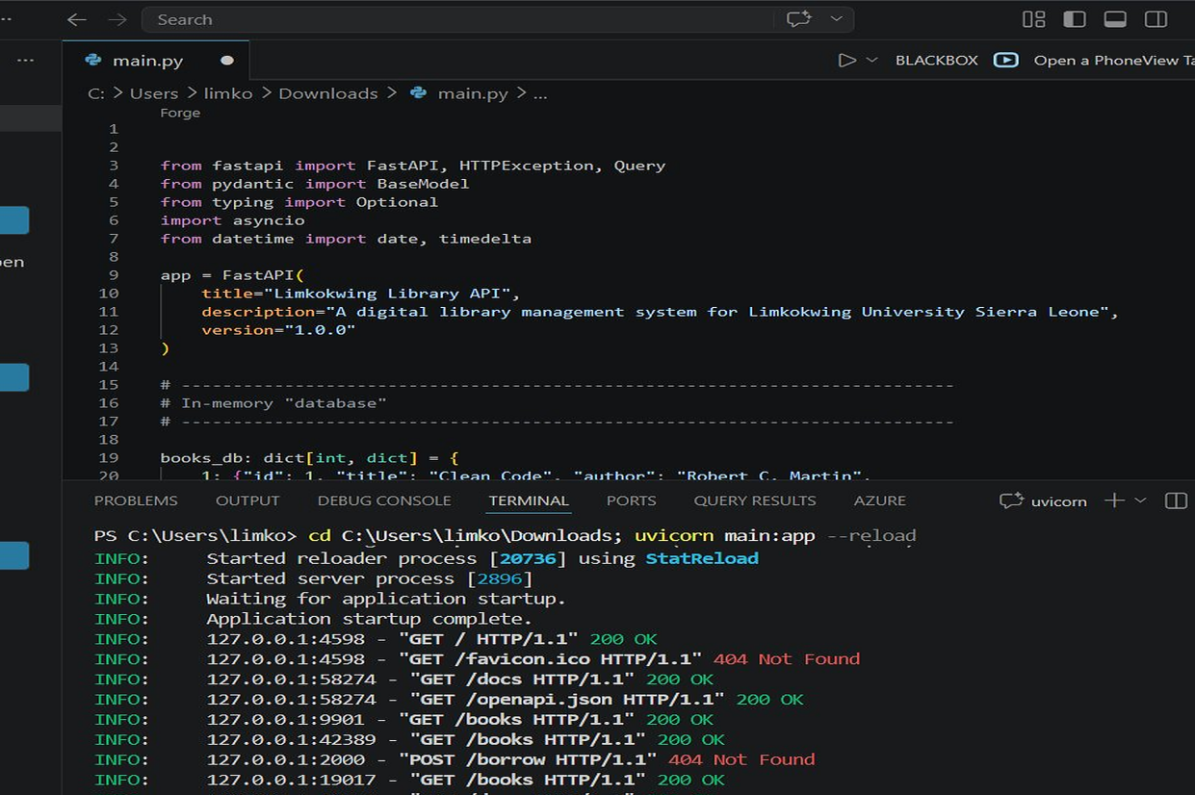
Figure 1: VS Code showing main.py source code and uvicorn server running in terminal with live request logs

B.5 Swagger UI Screenshots – All Endpoints Tested

Swagger UI Overview (All Endpoints)
The FastAPI Swagger UI automatically generated at http://127.0.0.1:8000/docs. All six endpoints are displayed with colour-coded HTTP methods: GET (blue), POST (green), PUT (orange). The Schemas section at the bottom shows the auto-generated BorrowRequest and ReturnRequest models from the Pydantic type annotations in the code.
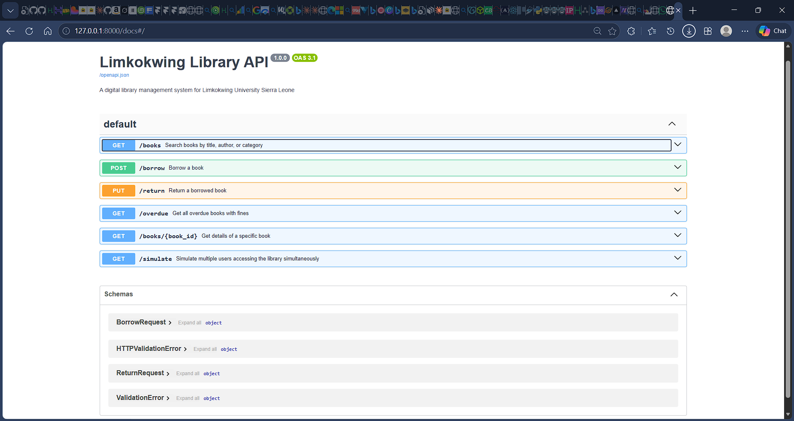

GET /books (Search Parameters Form)
The GET /books endpoint expanded showing its three optional query parameters: title, author, and category. The type shown as string | null confirms the Optional[str] annotation from the source code. The endpoint description was pulled automatically from the function's docstring.
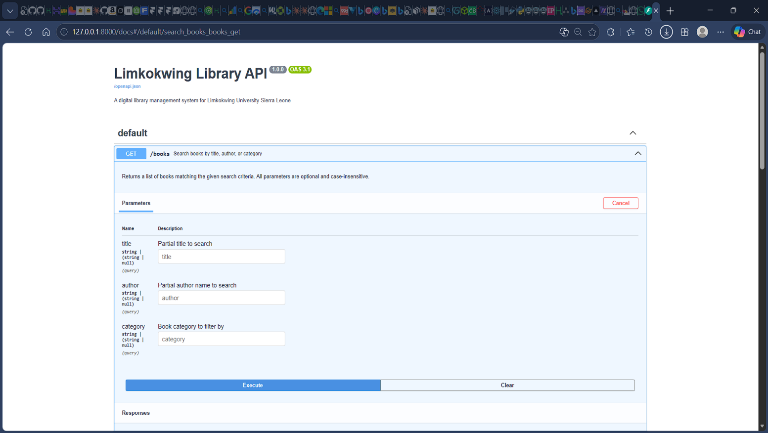

GET /books (200 OK — All Books Returned)
After executing GET /books with no filter, all five books are returned. The JSON shows each book's id, title, author, category, and availability. Design Patterns shows available: false as it is the pre-seeded overdue borrow. Response code is 200 OK, confirming the endpoint works correctly.
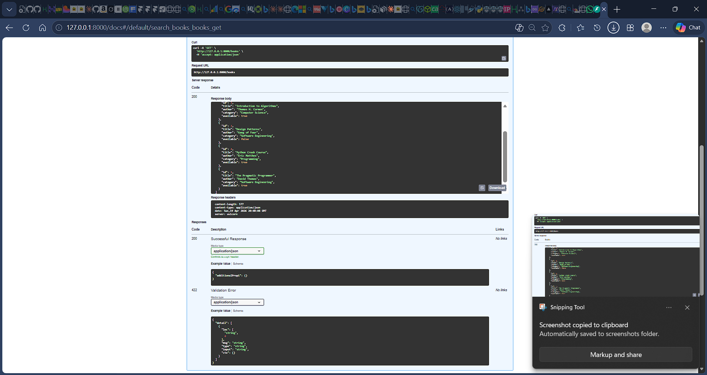

POST /borrow (Request Body)
The POST /borrow endpoint with the JSON request body: user_id 101 (Alusine Dumbuya) borrowing book_id 2 (Introduction to Algorithms). The curl command shown confirms the exact HTTP POST request including the Content-Type: application/json header sent to http://127.0.0.1:8000/borrow.

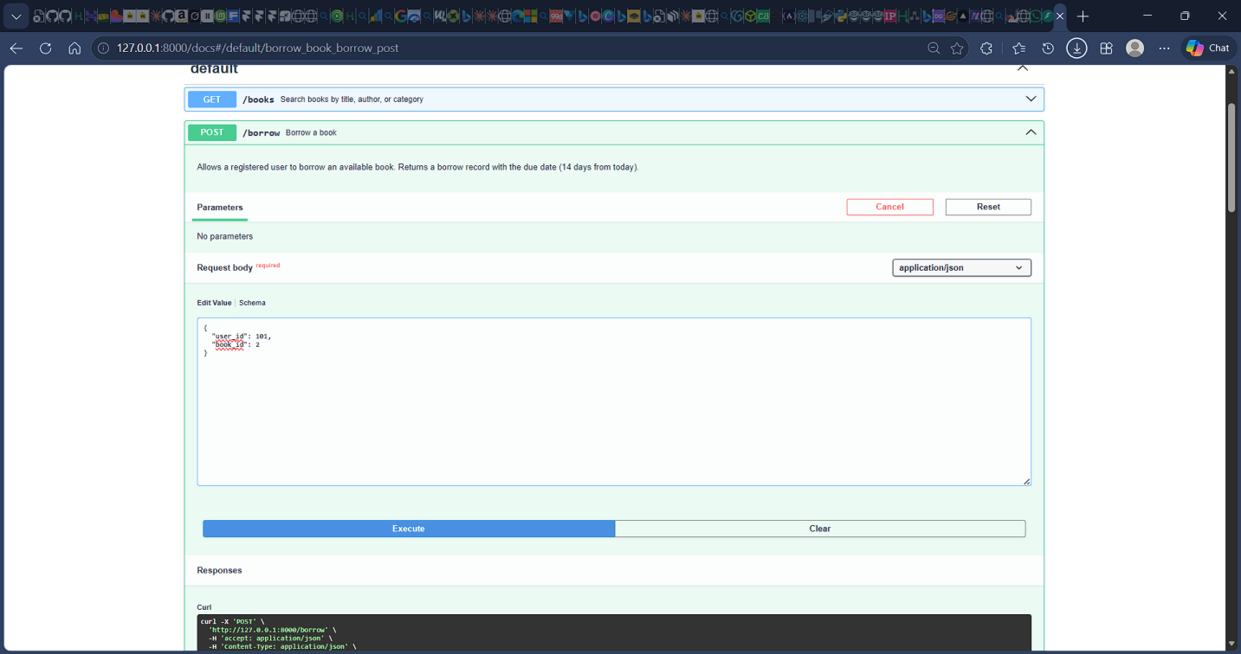

POST /borrow (201 Created — Success)
The server responds with HTTP 201 Created confirming 'Book borrowed successfully'. The borrow_record object shows the auto-generated borrow_id, the borrow_date (today), and the due_date calculated as exactly 14 days later. The returned field is false and fine is 0.0 at time of borrowing.
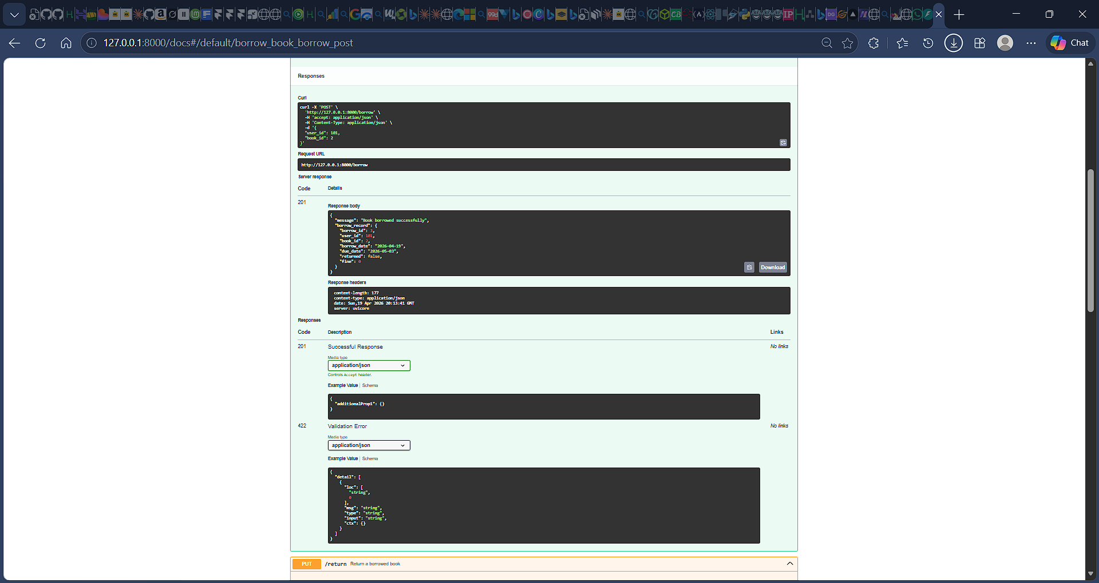

Screenshot 7 – PUT /return (Request Body)
The PUT /return endpoint with borrow_id: 2 and user_id: 101 in the request body. The PUT method is used because this operation updates an existing resource (the borrow record) rather than creating a new one, following REST semantics. Request URL is http://127.0.0.1:8000/return.

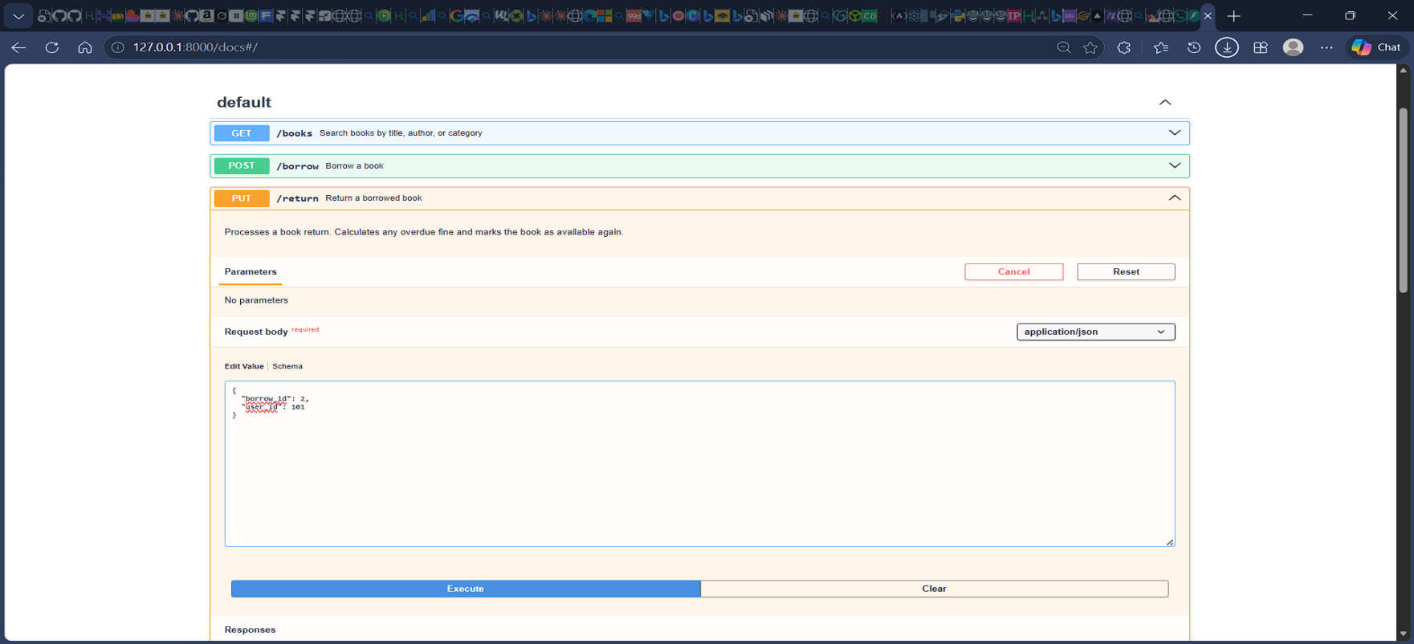

Screenshot 8 – PUT /return (400 Bad Request — Error Handling)
When attempting to return a book that has already been returned, the API correctly returns HTTP 400 Bad Request with the detail 'Book has already been returned'. This demonstrates the defensive validation logic — the if record['returned'] guard raises HTTPException(400) before any database update occurs, protecting data integrity.

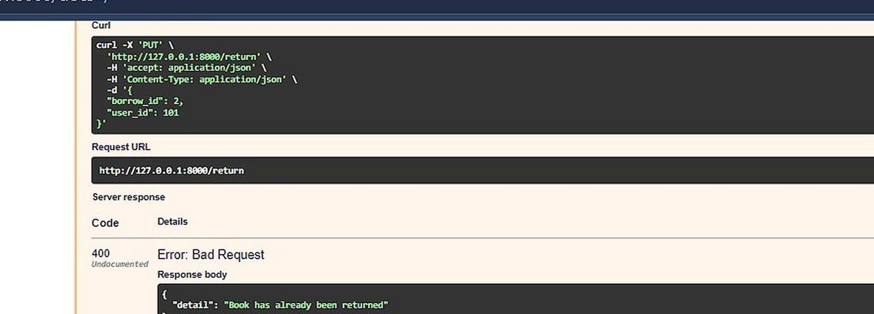
Figure 8: PUT /return — 400 Bad Request correctly raised when book was already returned

Screenshot 9 – GET /overdue (Overdue Tracking with Fine)
The GET /overdue endpoint returns the pre-seeded overdue record. The enriched JSON includes user_name 'Alusine Dumbuya', book_title 'Design Patterns', the borrow_date, due_date, the number of days_overdue, and the automatically calculated fine amount. This confirms both the calculate_fine() helper and the data enrichment logic work correctly.

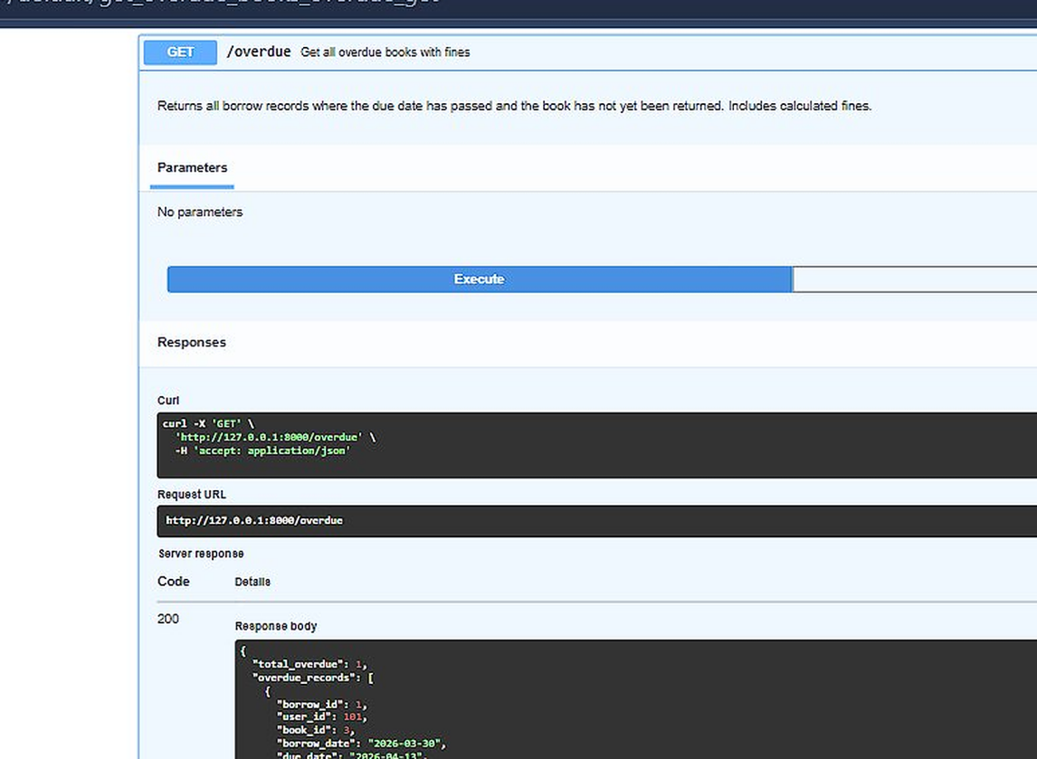
Figure 9: GET /overdue — 200 OK with enriched overdue record showing user, book, days overdue, and fine

Screenshot 10 – GET /books/1 (Single Book Detail)
Calling GET /books/1 returns the full details of Clean Code by Robert C. Martin: id 1, category Programming, available true. This confirms the path parameter routing works and the book is correctly marked as available after no active borrow exists for it.

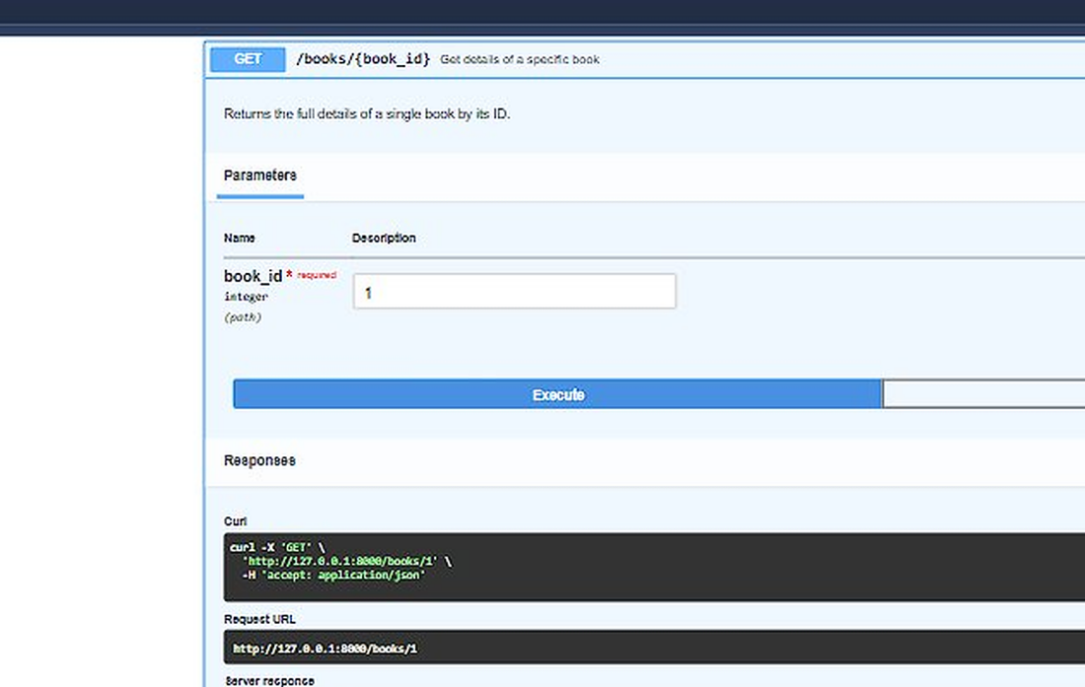
Figure 10: GET /books/1 — 200 OK with details of Clean Code (id: 1, available: true)

Screenshot 11 – GET /simulate (Async Concurrent Users)
The most important screenshot demonstrating asynchronous programming. asyncio.gather() runs 4 coroutines simultaneously. Results: User 101 borrows Clean Code (arrives at 0.1s); User 102 is blocked — Clean Code unavailable, race condition correctly handled (arrives at 0.2s too late); User 103 borrows Python Crash Course (different book, no conflict); User 101 returns Introduction to Algorithms. All four run concurrently without blocking each other.

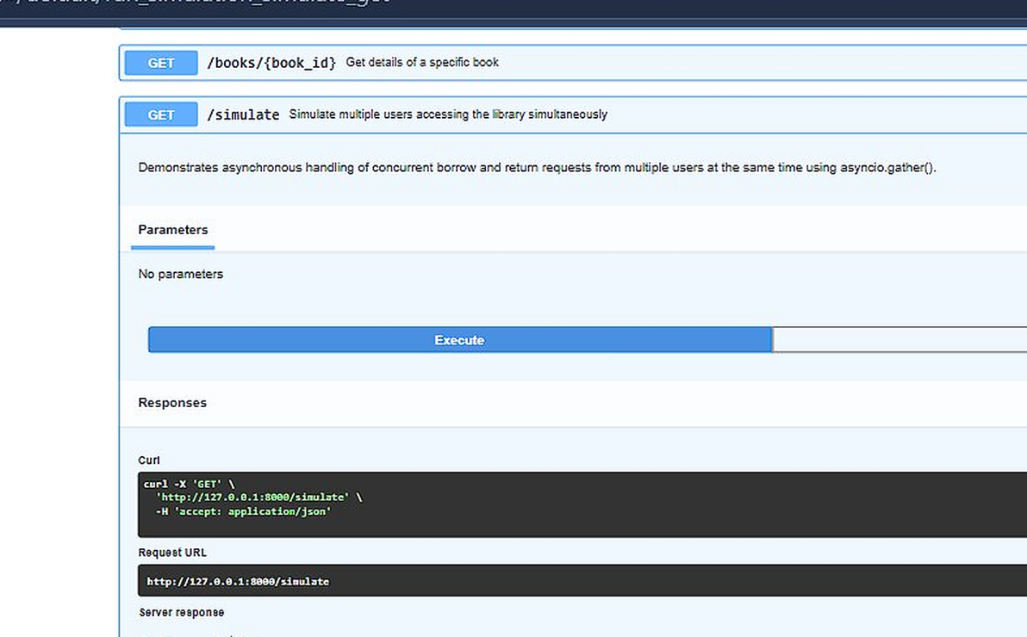
Figure 11: GET /simulate — asyncio.gather() running 4 concurrent users, demonstrating race condition handling

PART C – REFLECTION (25 Marks)

C.1 How APIs Improve Efficiency in Limkokwing Library Services (150–200 words)
APIs fundamentally transform library management from a slow, manual, and error-prone process into a fast, automated, and scalable digital service. Without a digital system, a Limkokwing librarian must physically search catalogues, manually record borrow transactions in ledgers, and calculate fines by hand — tasks that are time-consuming and highly prone to human error. With the Limkokwing Library API, a student can search hundreds of books in milliseconds from any device, borrow a book without visiting the library counter, and receive instant confirmation with a calculated due date. Staff no longer need to manually compute overdue fines; the /overdue endpoint returns the exact fine amount in real time. Because the API is stateless and asynchronous, it handles many students concurrently — especially critical during examination season. Furthermore, by exposing a standardised JSON interface, the API can be consumed simultaneously by a web portal, a mobile application, and the university's student information system without any changes to the backend logic. This architecture separates the user interface from business logic, allowing independent upgrades to either layer. In summary, APIs eliminate repetitive administrative work, reduce errors, extend library access beyond physical opening hours, and scale to meet growing student demand.

C.2 SDG Alignment – SDG 4: Quality Education
This project aligns directly with Sustainable Development Goal 4 — Quality Education, specifically Target 4.a: build and upgrade educational facilities that are inclusive, effective, and promote safe and non-violent, inclusive and effective learning environments for all. The library is the primary resource hub for students at Limkokwing University; however, manual library systems in institutions across Sierra Leone restrict access to knowledge due to long queues, lost or incomplete borrow records, and limited opening hours. By digitising the library through an open-source RESTful API, this project removes those access barriers. Any student with a smartphone or laptop can search the full catalogue, check real-time book availability, and borrow books remotely — regardless of their physical location or time of day. The use of open-source Python and FastAPI means the solution is cost-free beyond server hosting, making it directly replicable by other institutions across Sierra Leone and the broader West African region. This contributes concretely to SDG 4's core principle of providing equitable, inclusive, and quality education for all.

C.3 Challenges Faced During Design and Implementation
- Async race condition logic: The most complex challenge was correctly modelling race conditions in the /simulate endpoint. Initially both User 101 and User 102 were succeeding because the availability check and book flag-update were not treated atomically. The solution was to ensure each coroutine checks and updates availability within the same synchronous execution block, so only the coroutine that runs first can claim the book.
- JSON response design: Deciding which fields to include in each response required balancing completeness with payload efficiency. The /overdue endpoint in particular returned raw borrow records that were meaningless without context — this required adding data enrichment logic to join user names and book titles from the other in-memory dictionaries before returning the response.
- Type annotation consistency: Ensuring Pydantic schema types matched the actual dictionary values required careful coordination. Date fields had to be stored as ISO format strings for JSON serialisability, while Python date objects were needed for arithmetic — requiring consistent use of str() when storing and date.fromisoformat() when computing.
- HTTP method selection: Choosing between POST and PUT for the return endpoint required applying REST semantics. PUT was correct because the operation modifies an existing borrow record rather than creating a new resource. Using POST would have implied creating a new return resource, which is semantically incorrect.

C.4 Suggested Improvement if the Library Expanded
If the Limkokwing Library expanded to include e-books, journal subscriptions, and inter-campus lending across multiple Limkokwing campuses, the single most valuable technical improvement would be replacing the in-memory dictionary data store with a persistent relational database — specifically PostgreSQL integrated via SQLAlchemy with async support (asyncpg). This would allow all borrow records, fines, and user data to persist across server restarts, support complex analytical queries such as most-borrowed books by department or overdue rates by student cohort, and handle concurrent database writes reliably through ACID transaction management. Alongside this, implementing JWT-based user authentication using FastAPI's built-in OAuth2PasswordBearer scheme would ensure that only verified students and library staff can access sensitive endpoints such as /borrow, /return, and /overdue — which is essential for a multi-campus environment shared across international locations.

PART D – GITHUB OPEN SOURCE SETUP (15 Marks)

All source code for this assignment has been published as a public open-source repository on GitHub under the account Eager1337. The repository contains the full FastAPI implementation, a descriptive README.md, and a Python .gitignore. The repository is publicly accessible and qualifies as a Digital Public Good (DPG) in line with the assignment's open-source requirement.

D.1 Repository Information

Field | Details
Repository Name | limkokwing-library-api
GitHub Username | Eager1337
Repository URL | https://github.com/Eager1337/limkokwing-library-api
Visibility | Public (Open Source / DPG eligible)
Project Title | Limkokwing University Library Management API
Language / Framework | Python 3.11+ / FastAPI 1.0.0
Description | A RESTful API for managing the Limkokwing University library system. Supports book search, borrow/return transactions, overdue tracking with automatic fine calculation, and concurrent user simulation using asyncio.gather().
Lecturer Collaborator | amandus.bcoker@limkokwing.edu.sl — added via Settings > Collaborators and teams

D.2 Repository File Contents

File | Contents and Purpose
main.py | Complete FastAPI source code. Implements all five endpoints (GET /books, POST /borrow, PUT /return, GET /overdue, GET /books/{book_id}) plus the async /simulate endpoint. Includes Pydantic type-annotated schemas (BorrowRequest, ReturnRequest), calculate_fine() helper, in-memory data store with 5 books and 3 users, and the asyncio.gather() concurrent simulation.
README.md | Project title and one-paragraph description. Tech stack table listing FastAPI, Uvicorn, Pydantic, asyncio, Python 3.11+. Step-by-step installation and run instructions (pip install, uvicorn startup). Full endpoint reference table with HTTP methods and descriptions. JSON example request bodies for borrow and return operations. SDG 4 Quality Education alignment statement. License declaration.
.gitignore | Standard Python gitignore file. Excludes: __pycache__/ and *.pyc compiled files, venv/ and .venv/ virtual environment folders, .env secret files, .idea/ and .vscode/ IDE configuration directories, *.log files, and dist/ build/ package output directories.

D.3 GitHub Setup Steps
- Step 1: Created a new public repository named limkokwing-library-api on GitHub under account Eager1337.
- Step 2: Wrote README.md with full project description, installation guide, endpoint table, usage examples, and SDG 4 alignment.
- Step 3: Added main.py — the complete FastAPI source code as described in Part B.
- Step 4: Added .gitignore to exclude Python cache files, virtual environments, secrets, and IDE folders from version control.
- Step 5: Committed all files to the main branch with clear commit messages describing each change.
- Step 6: Added the lecturer (amandus.bcoker@limkokwing.edu.sl) as a collaborator via Settings > Collaborators and teams > Add people.

